**COIT13229**

**Applied Distributed System**

**Zookeeper Test Documentation**

|  |  |
| --- | --- |
| **Name:** | Ujjwal Dhakal |
| **Student Number:** | 12222900 |

|  |  |
| --- | --- |
| **Name:** | Sultan Zahid |
| **Student Number:** | 12274082 |

Table of Contents

Tests for Zookeeper version of coPlay 3

Automated Fault Tolerance Test Cases 3

FT-3: Peer Crash During Game Session 3

FT-2: Message Reorder 4

FT-1: Lag Simulation Test 4

Manual Test Cases 5

TC-1: Chat Message Broadcast 5

TC-2: Tower Click Reflects Across Peers 7

TC-3: Reset Vote Mechanism 9

TC-4: Polling update from Multiple Peers 11

TC-5: Disk Selector Sync 14

TC-6: Browser Refresh Mid-Game 18

TC-7: Concurrent Message Posting 21

TC-8: UI Responsiveness 22

TC-9: Shutdown Peer via Link 30

TC-10: Disk Movement Test (3 to 8 Disks) 32

Test Summary 37

# Tests for Zookeeper version of coPlay

This document provides structured and detailed test results for the Zookeeper-based version of the coPlay system. Tests include automated fault tolerance scenarios and manual interaction tests. Observations, outcomes, and justifications for failures are recorded for transparency

## Automated Fault Tolerance Test Cases

### FT-3: Peer Crash During Game Session

**Test Type:** Automatic

**Description**: Simulates a peer crashing mid-game. Messages are sent before and after the crash to check for message delivery.

**Expected:** All peers except the crashed one should continue receiving and showing messages.

**Actual:** Second message after crash was not received by live peer.

**Status:** FAIL

**Screenshot:  
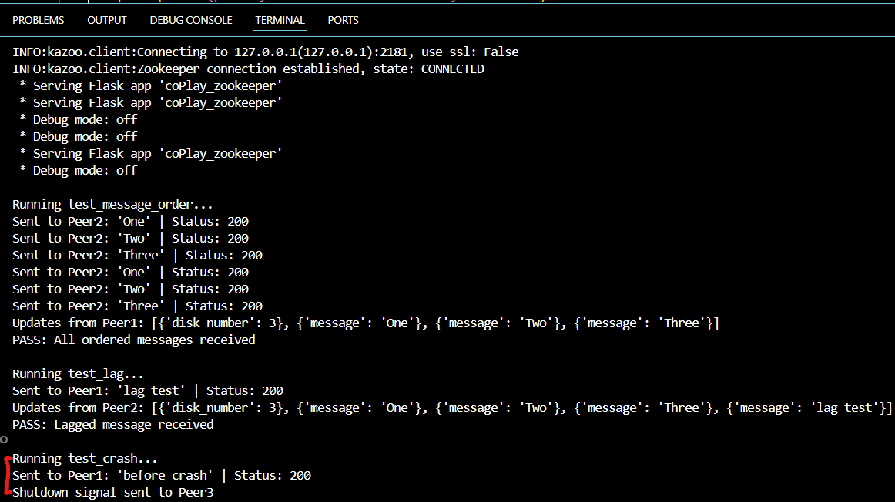**

Fig:

**Justification:** Zookeeper watchers are event-based and do not guarantee message delivery after node removal. No fallback polling logic implemented.

### FT-2: Message Reorder

**Test Type**: Automatic

**Description:** Sends three chat messages (First, Second, Third) in quick succession to see if all are received.

**Expected**: All messages should be received, order may vary.

**Actual**: All messages received successfully.

**Status:** PASS

**Screenshot:**

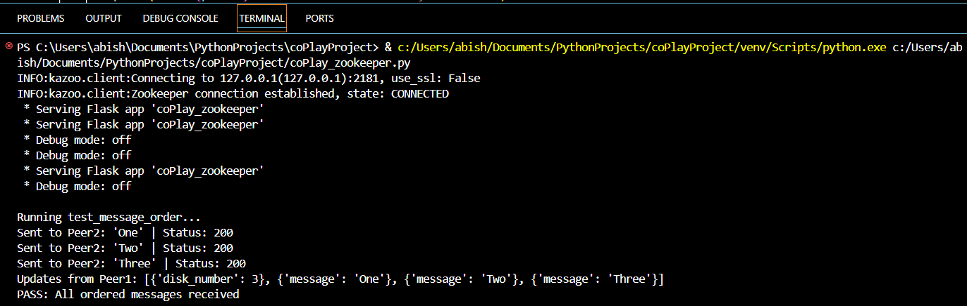

Fig: Message reorder was successfully executed

**Justification:** Zookeeper appends nodes in sequence and ordering can be managed on client by sorting children nodes.

### FT-1: Lag Simulation Test

**Test Type:** Automatic

**Description:** Injects a 2-second delay before reading updates after sending a message.

**Expected:** Message should appear in the updates despite the delay.

**Actual:** Message successfully received.

**Status:** PASS

**Screenshot:  
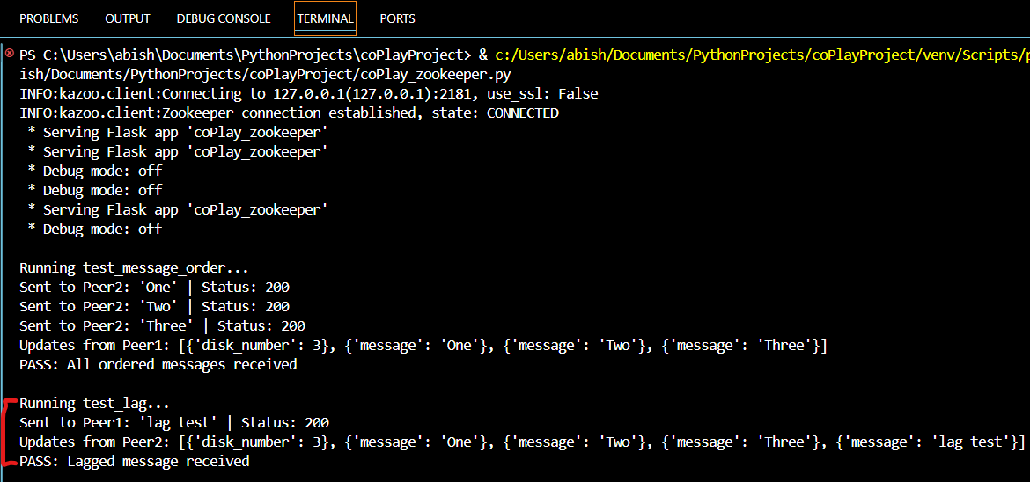**

Fig: Lag Simulation test was successfully executed

**Justification:** Watchers continued to trigger update accumulation even during delay period.

## Manual Test Cases

### TC-1: Chat Message Broadcast

**Test Type:** Manual

**Description:** Sends 'Hello world' message and checks if it appears on all peers along with follow up message “Hi”.

**Expected:** Message is displayed on every peer in chat log in scrollable version.

**Actual:** Message successfully displayed across all peers and was scrollable.

**Status:** PASS

**Screenshots:**

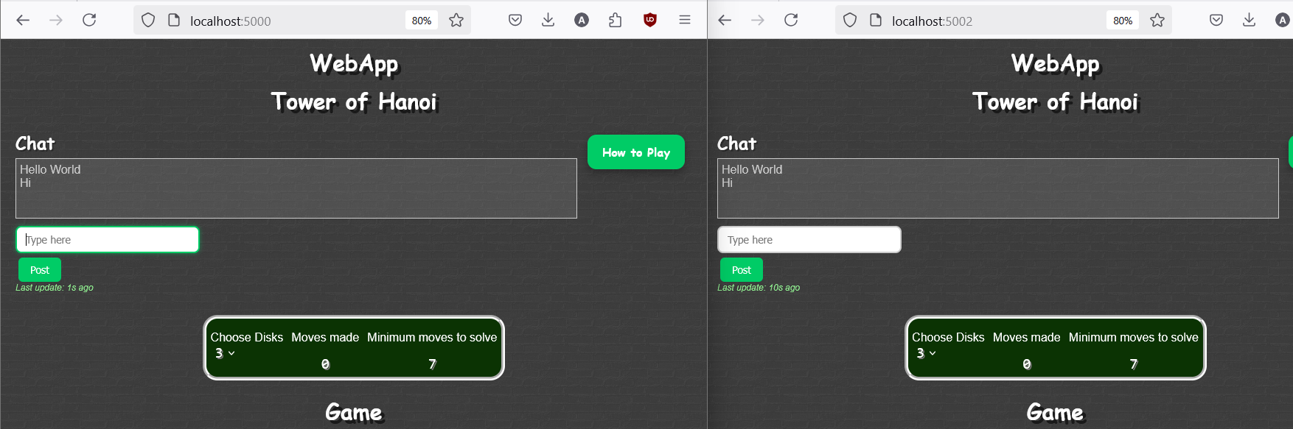

Fig: Successful message passing across peers  
  
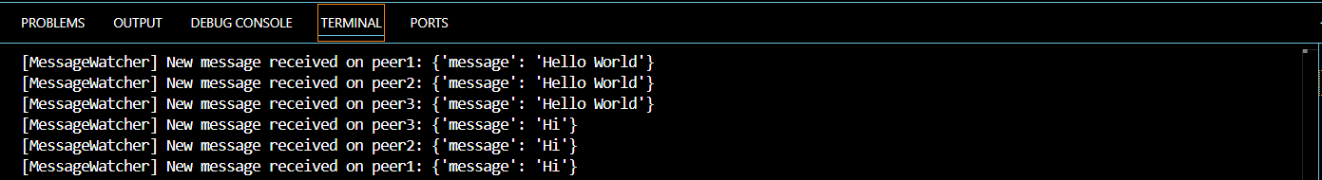

Fig: Message updates in console

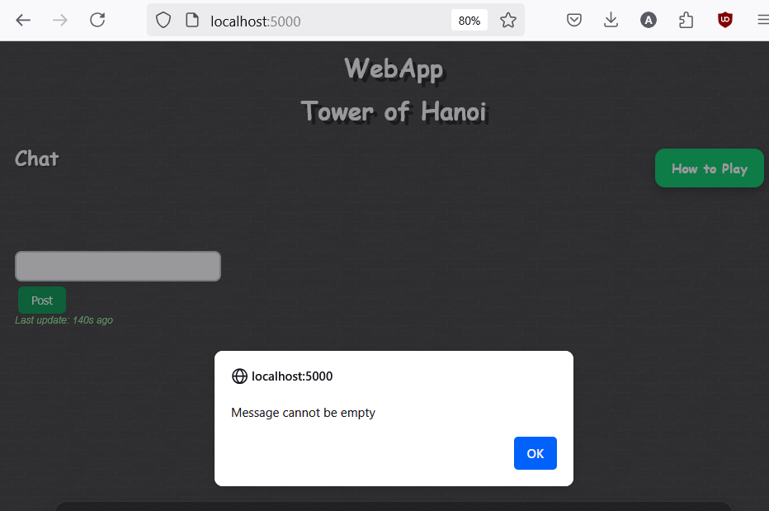

Fig: Message validation before passing through peers

### TC-2: Tower Click Reflects Across Peers

**Test Type:** Manual

**Description:** Click tower 1 on peer1 and observe if tower highlighting is reflected on other peers.

**Expected:** Same tower gets highlighted across all browsers.

**Actual:** Tower highlight appears across all peers.

**Status:** PASS

**Screenshots:**

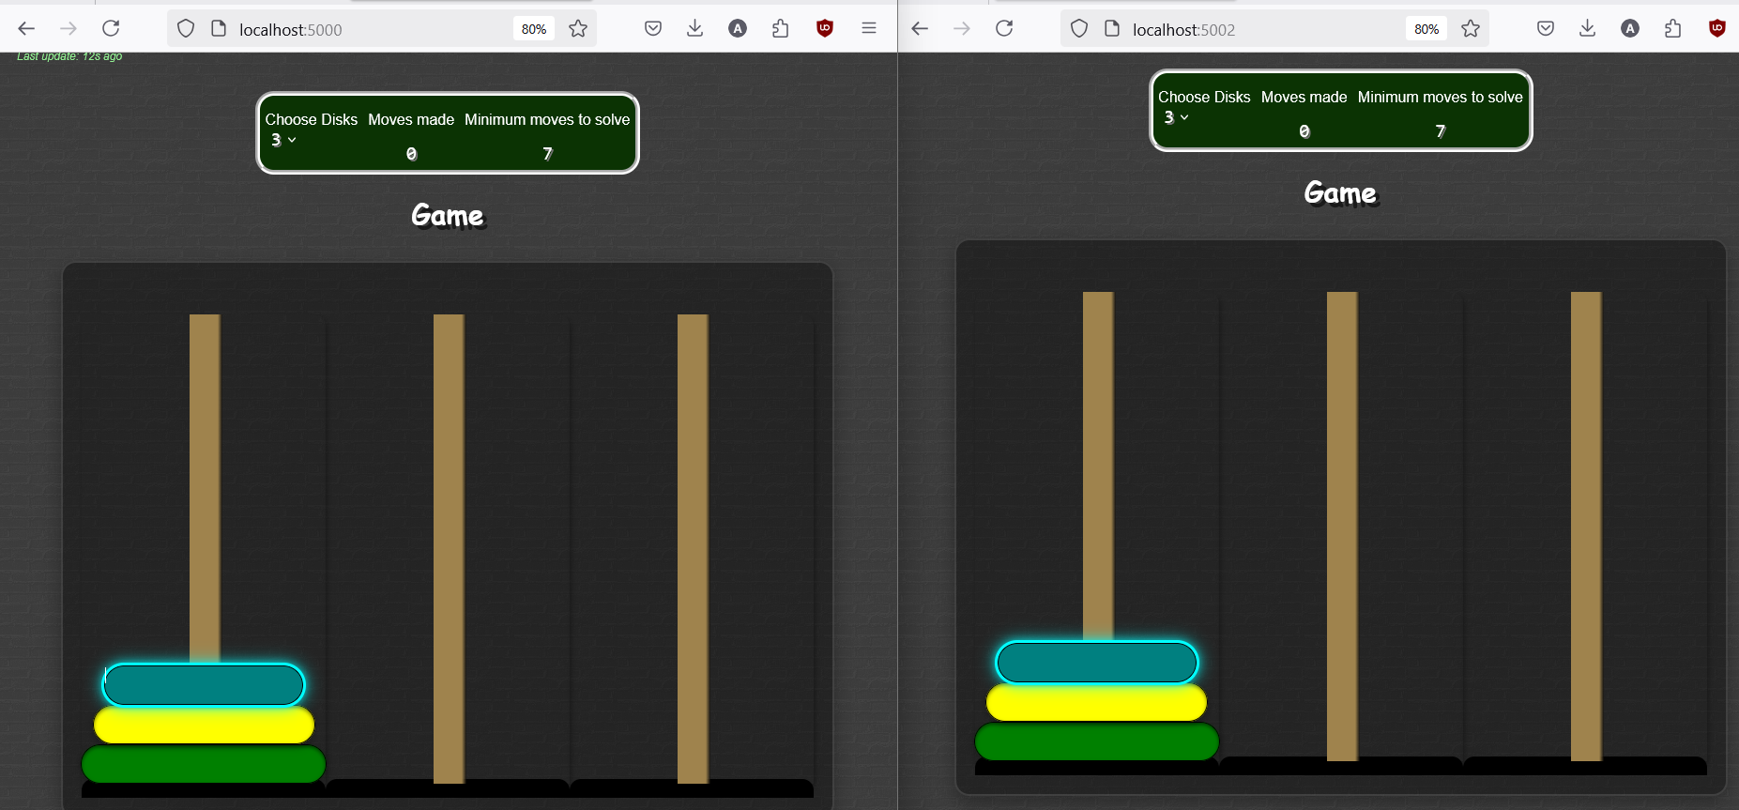

Fig: Tower highlights across all peers in same tower

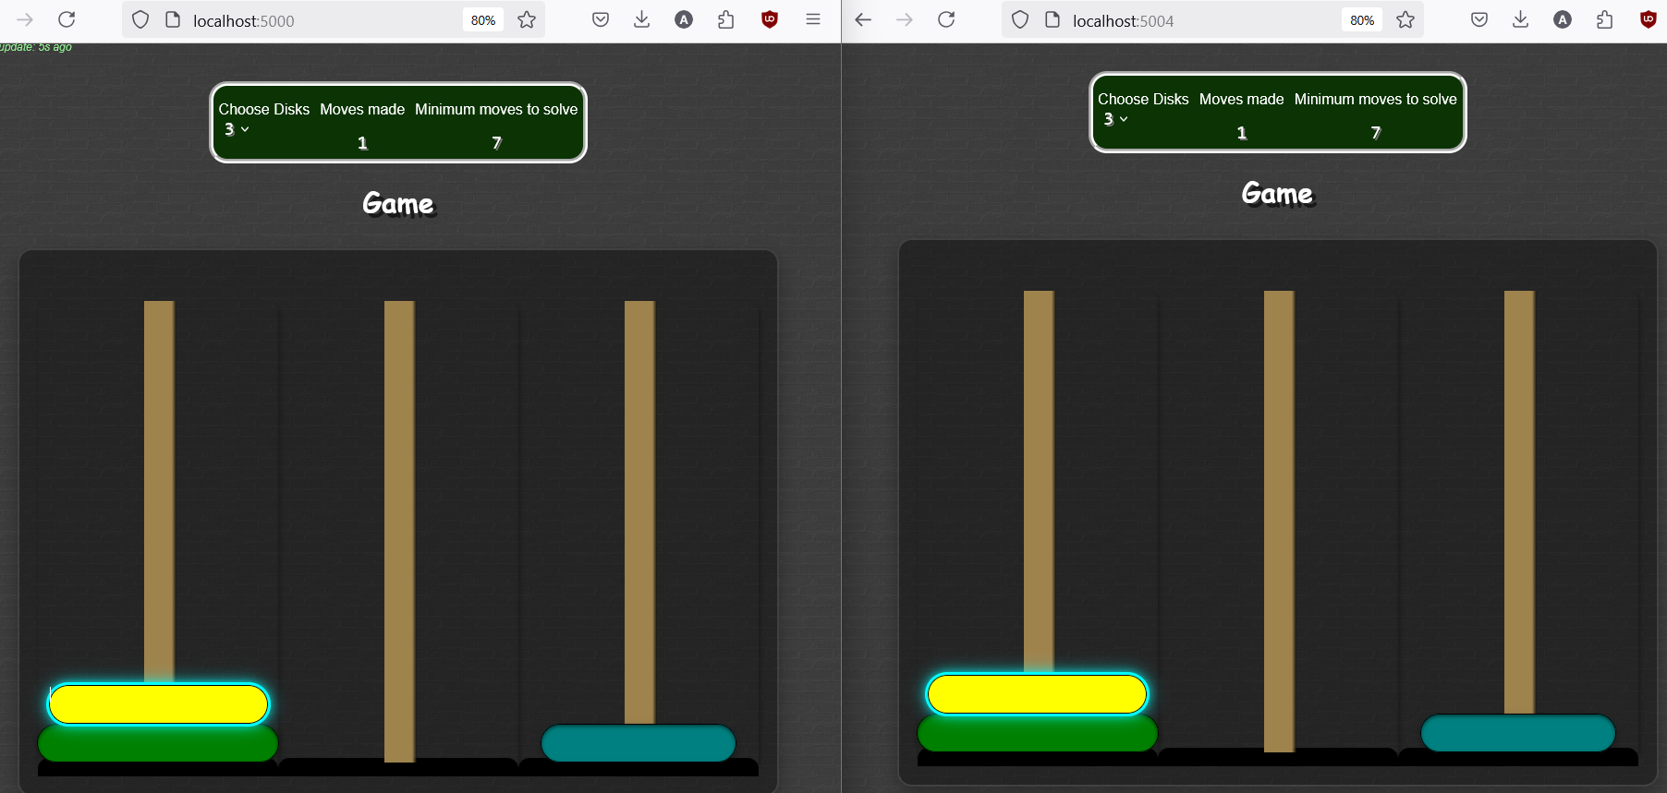

Fig: All disks highlights across all peers

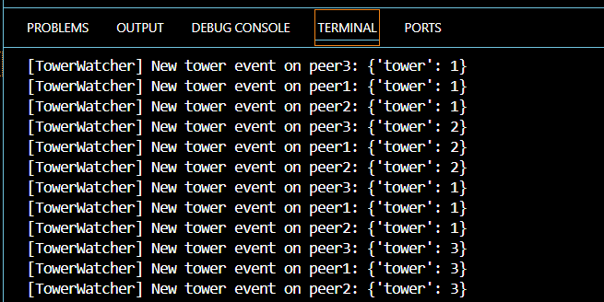

Fig: Tower events updates in console

### TC-3: Reset Vote Mechanism

**Test Type:** Manual

**Description:** Initiate reset request on one peer and reset vote on another. Observe game reset.

**Expected:** Game resets after one peer accepts request. Each peer gets reset request to confirm while requesting peer receives a waiting message.

**Actual:** All other peers get reset request while requesting peer gets waiting message. Game resets across all peers consistently after accepting request.

**Status:** PASS

**Screenshots:**

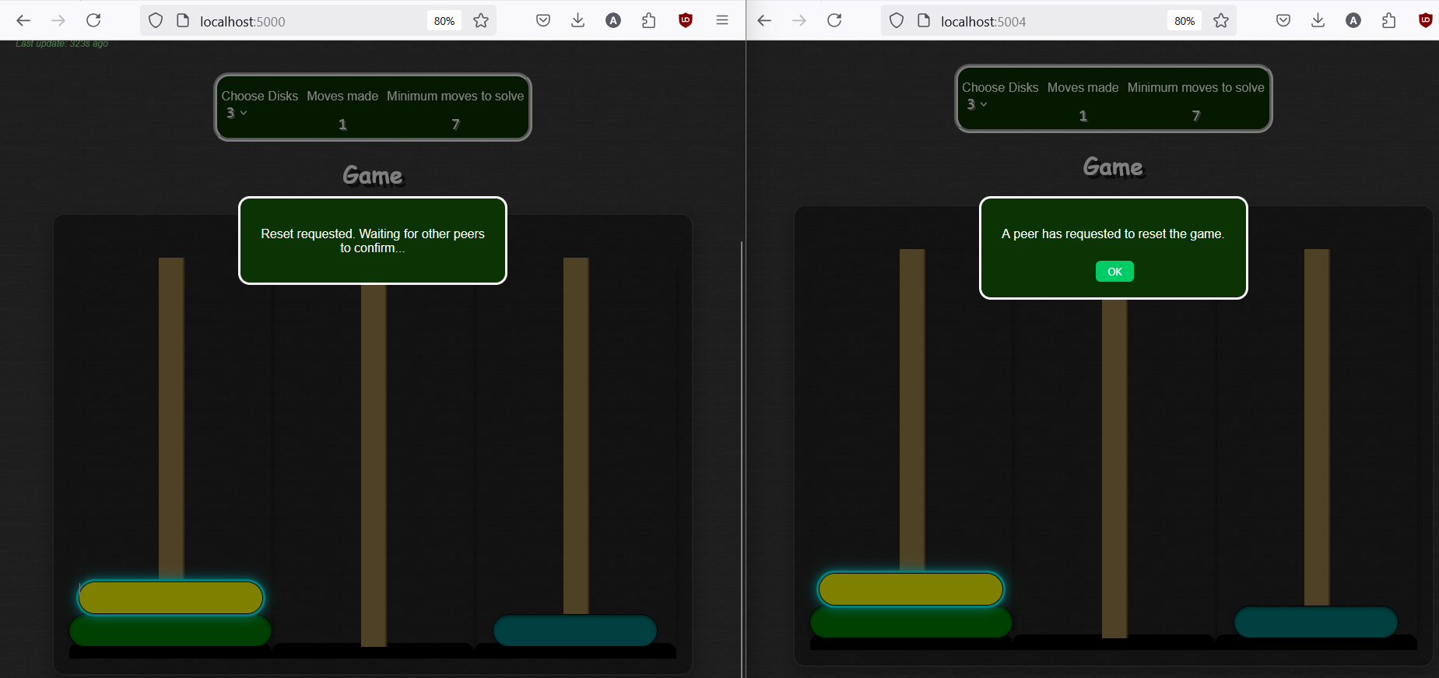

Fig: Reset request sent across all peers with waiting message on requester

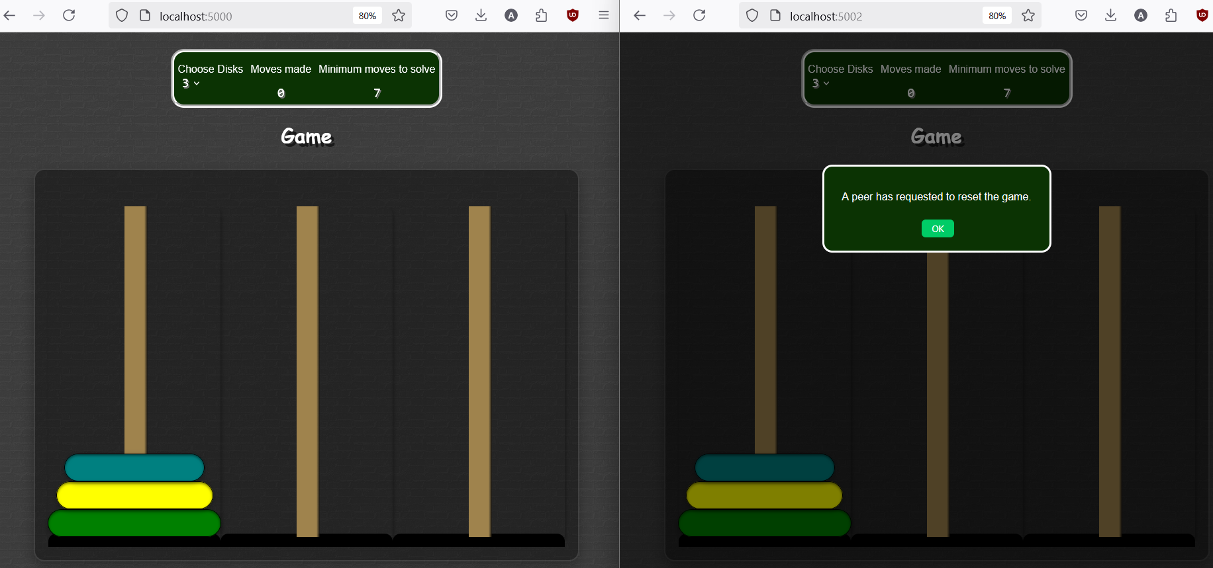

Fig: Reset request pending for inactive peer while other peer accepts request

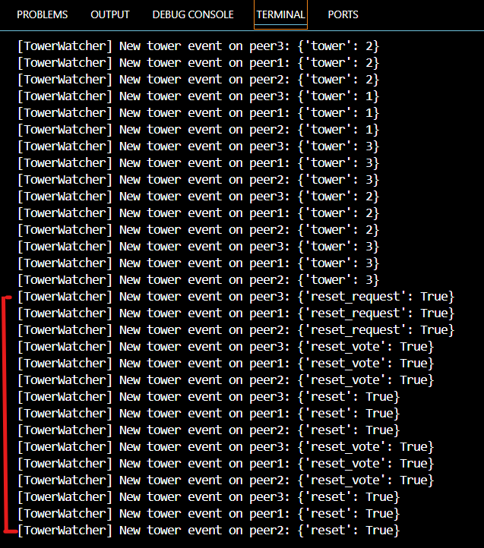

Fig: Reset activities representation in console

### TC-4: Polling update from Multiple Peers

**Test Type:** Manual

**Description:** Send actions from one peer and check updates appear on others via /update polling.

**Expected:** All events (chat, disk, reset) reflect consistently on console.

**Actual:** Consistency maintained throughout interactions and console gets update.

**Status:** PASS

**Screenshots:**

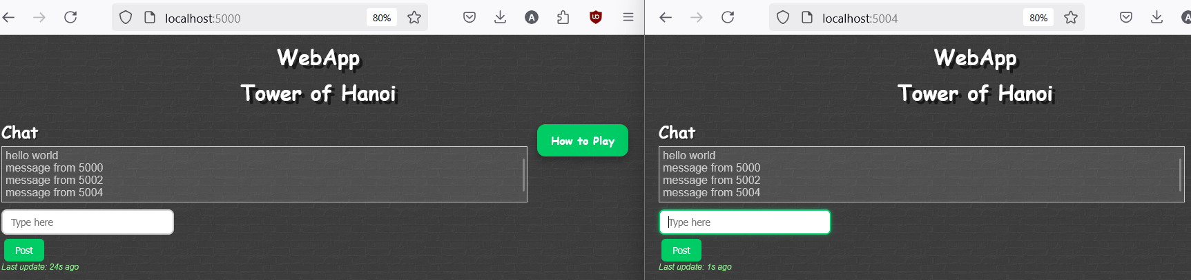  
Fig: Sending messages across peers

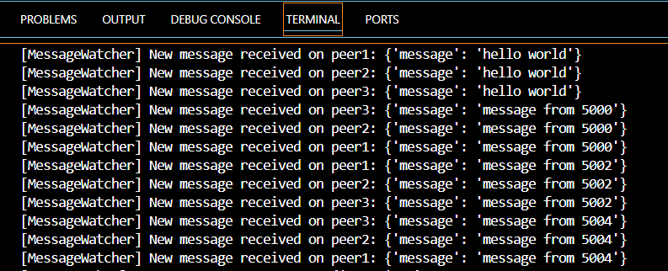

Fig: Message updates consistently appears in console

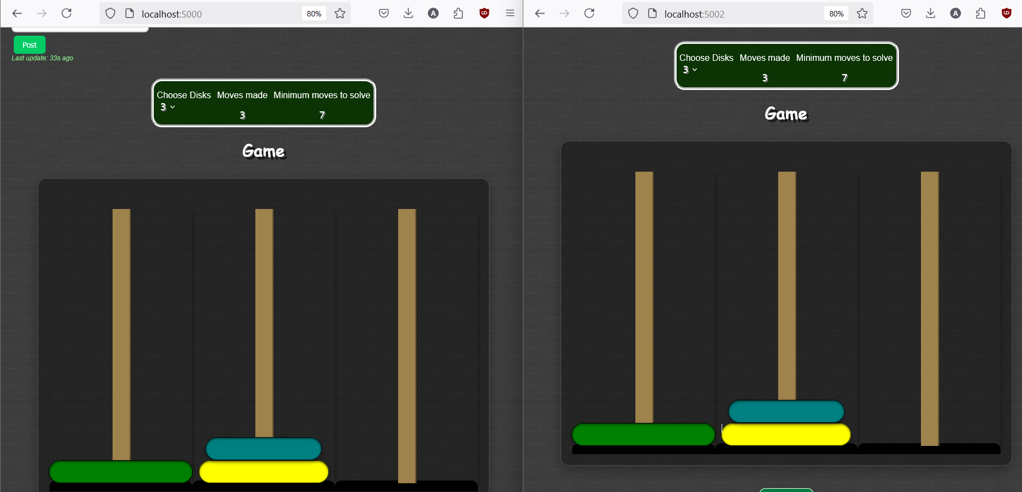

Fig: Disk movements across peers

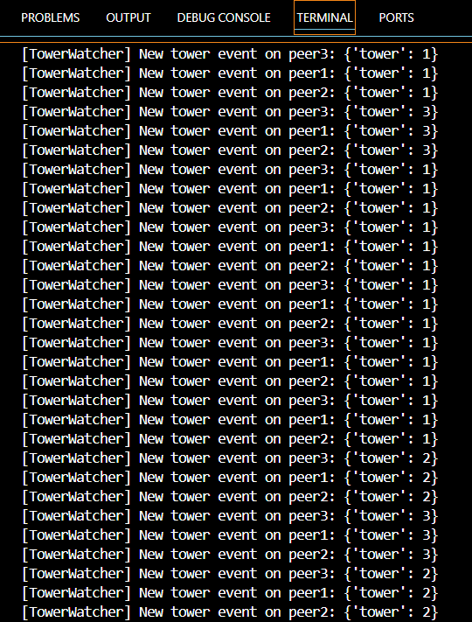

Fig: Tower movement updates consistently appear in console

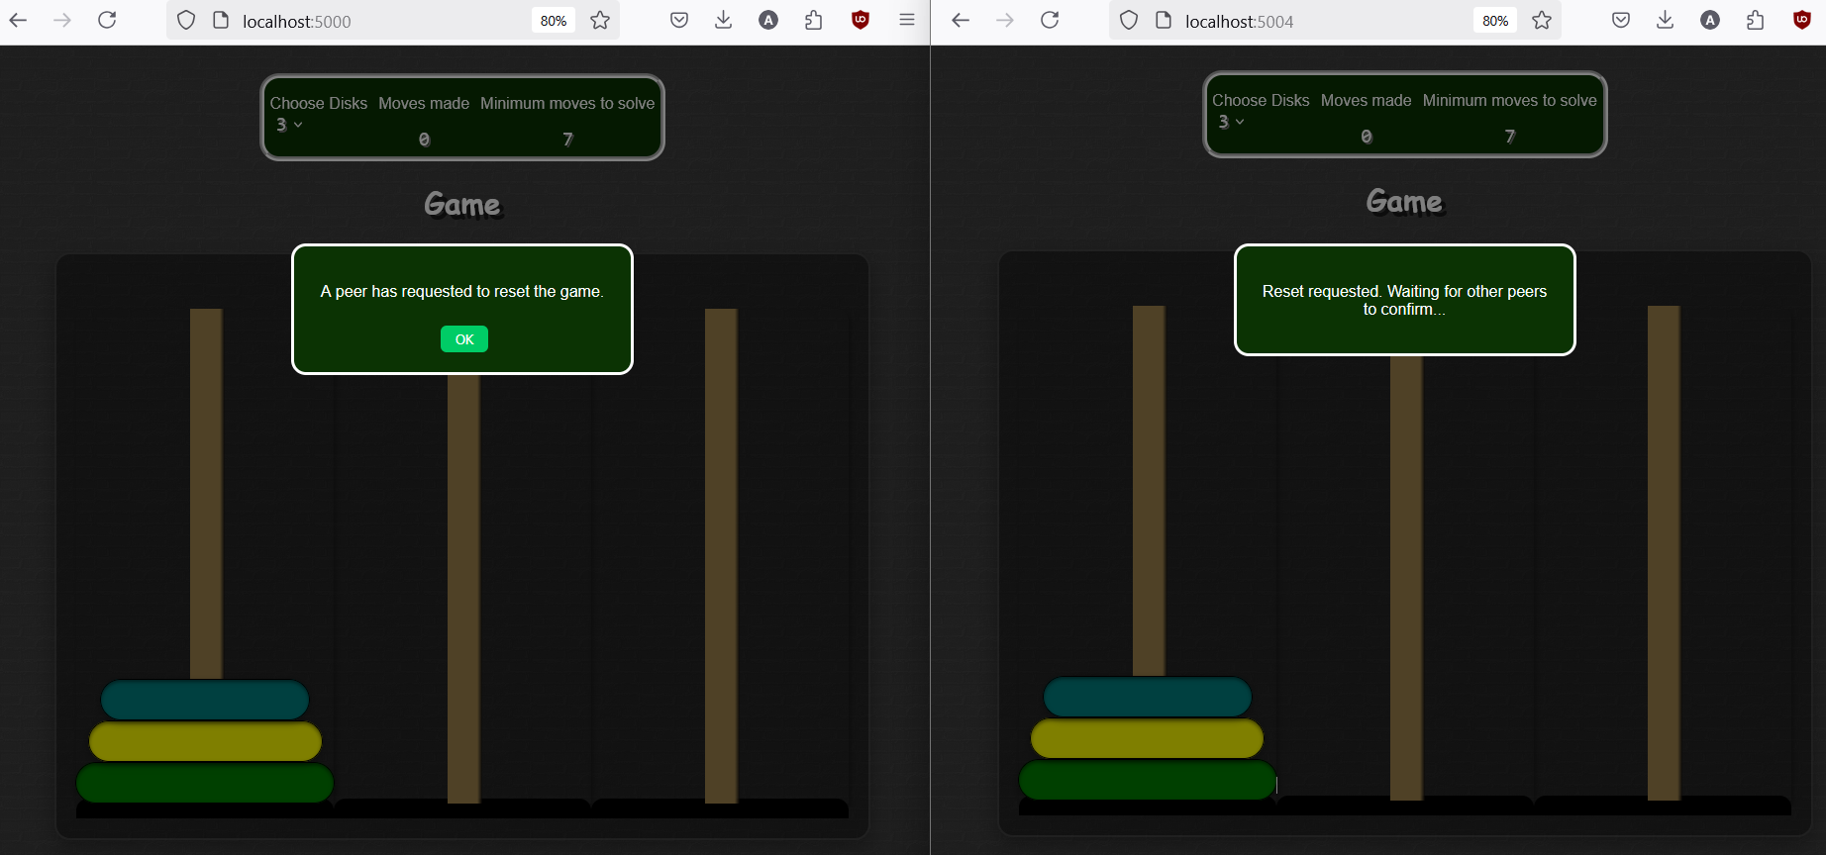

Fig: Sending reset request across peers

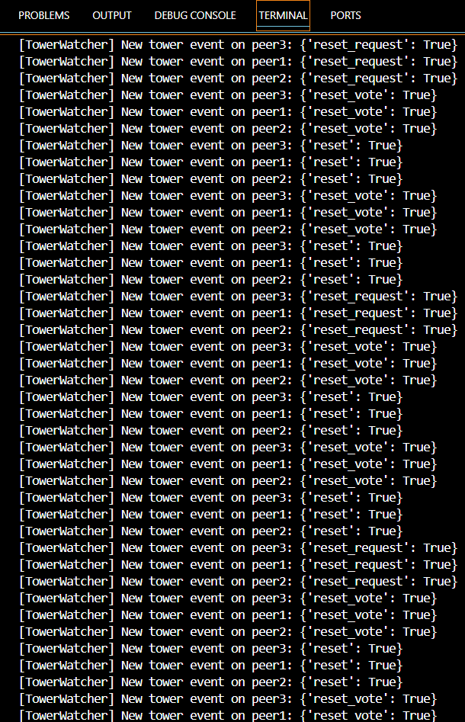

Fig: Reset requests consistently appear in console

### TC-5: Disk Selector Sync

**Test Type:** Manual

**Description:** Change disk count from 3 to 8 on one peer. Observe changes on others.

**Expected:** New disk count appears on all peers immediately across all peers. Any peer can trigger changes in number of disks

**Actual:** Disk count update visible across all peers.

**Status:** PASS

**Screenshots:**

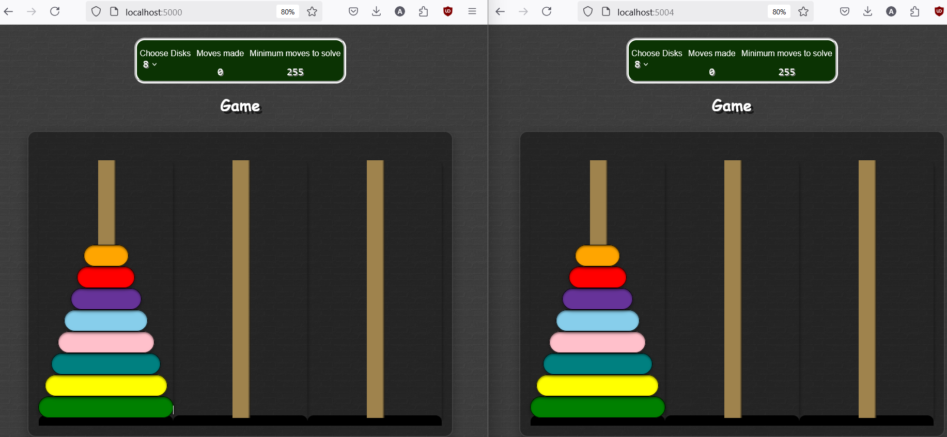

Fig: Game updates with 8 disks across all peers

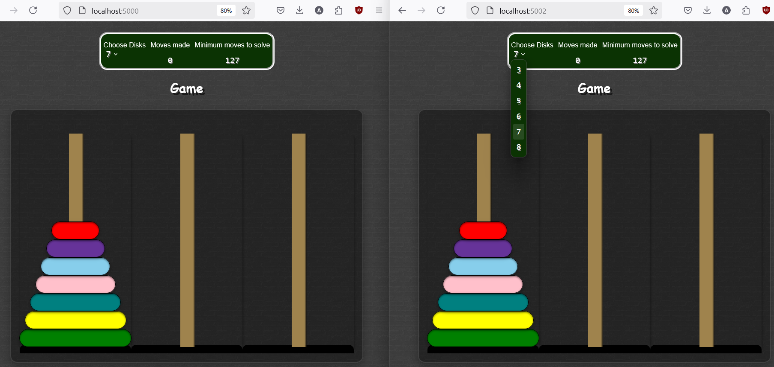

Fig: Game updates with 7 disks across all peers

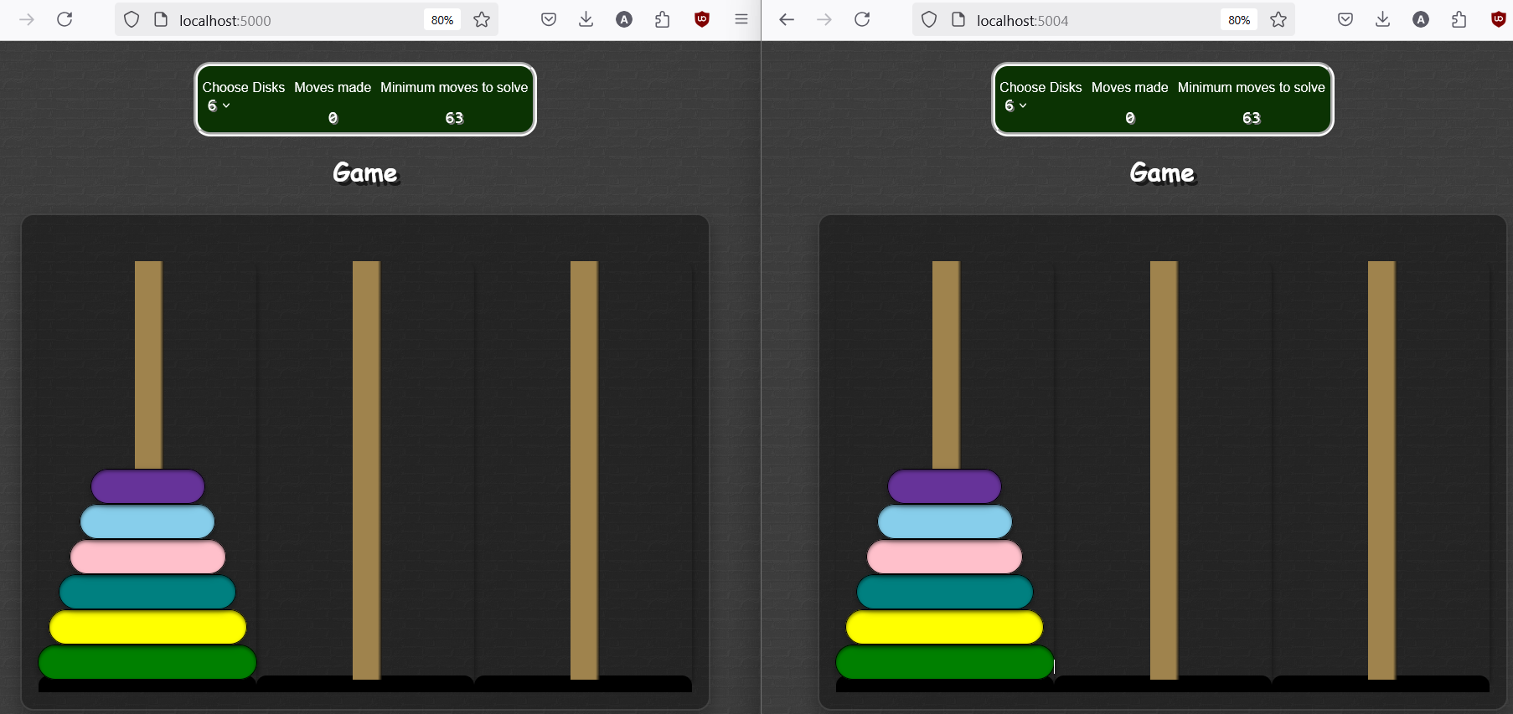

Fig: Game updates with 6 disks across all peers

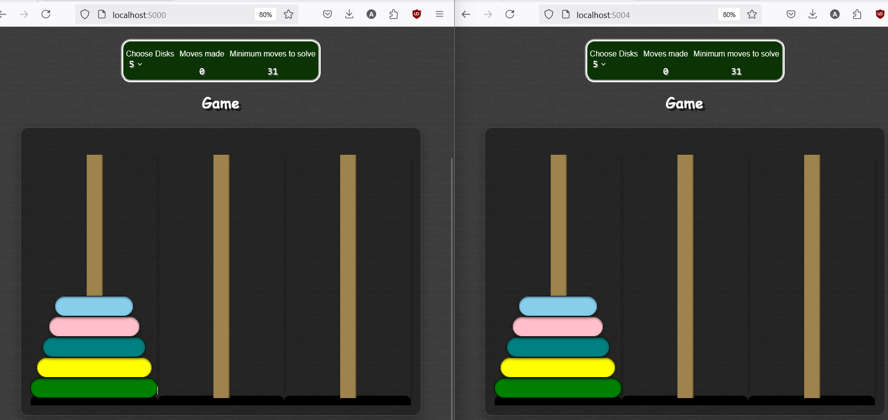

Fig: Game updates with 5 disks across all peers

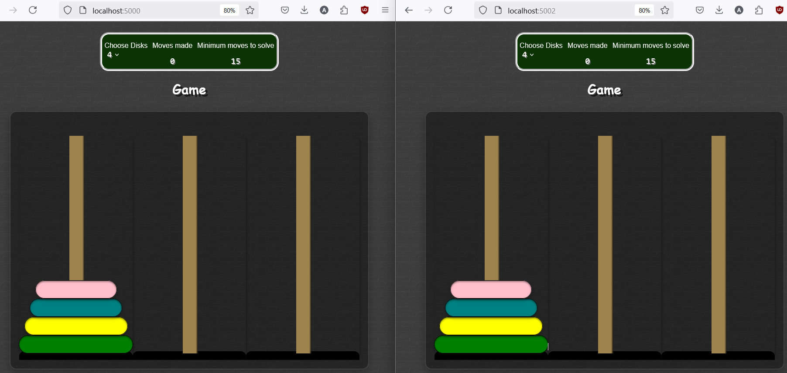

Fig: Game updates with 4 disks across all peers

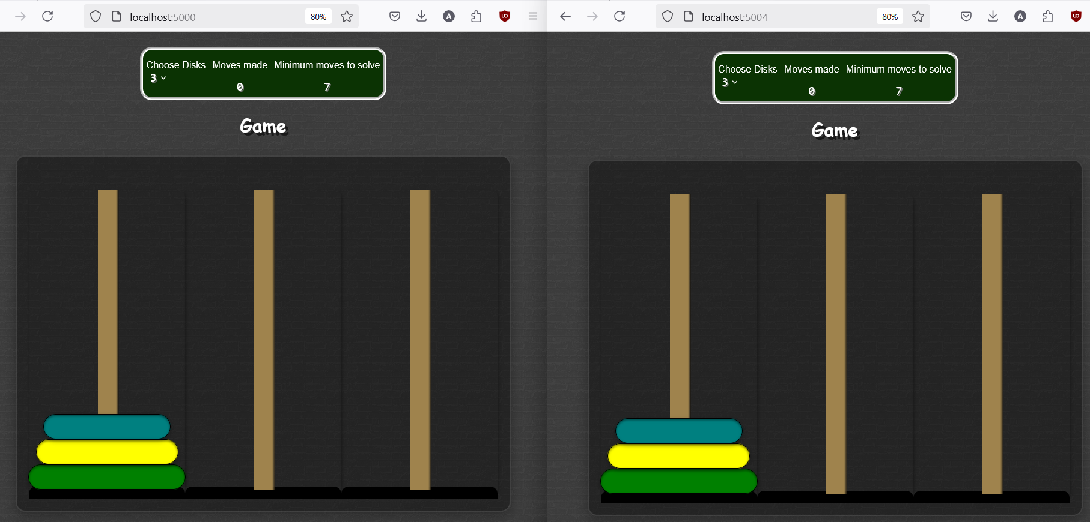

Fig: Game updates with 3 disks across all peers

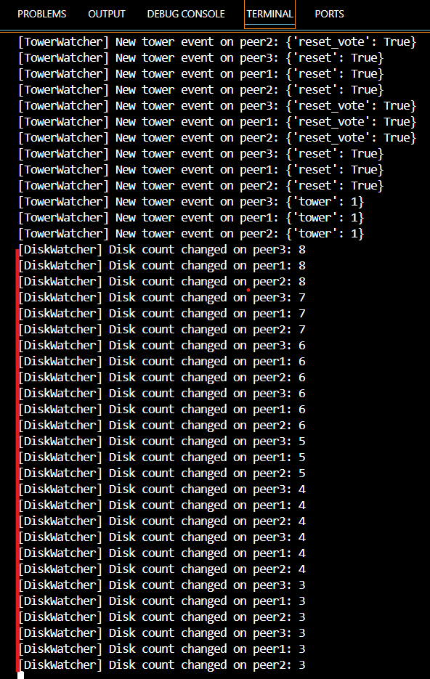

Fig: Disk change updates in console

### TC-6: Browser Refresh Mid-Game

**Test Type**: Manual

**Description:** Refresh browser while game is ongoing and observe if state persists.

**Expected:** Game state is restored automatically.

**Actual:** Game state is lost after refresh. Starts a fresh new game across all peers

**Status:** FAIL

**Screenshots:**

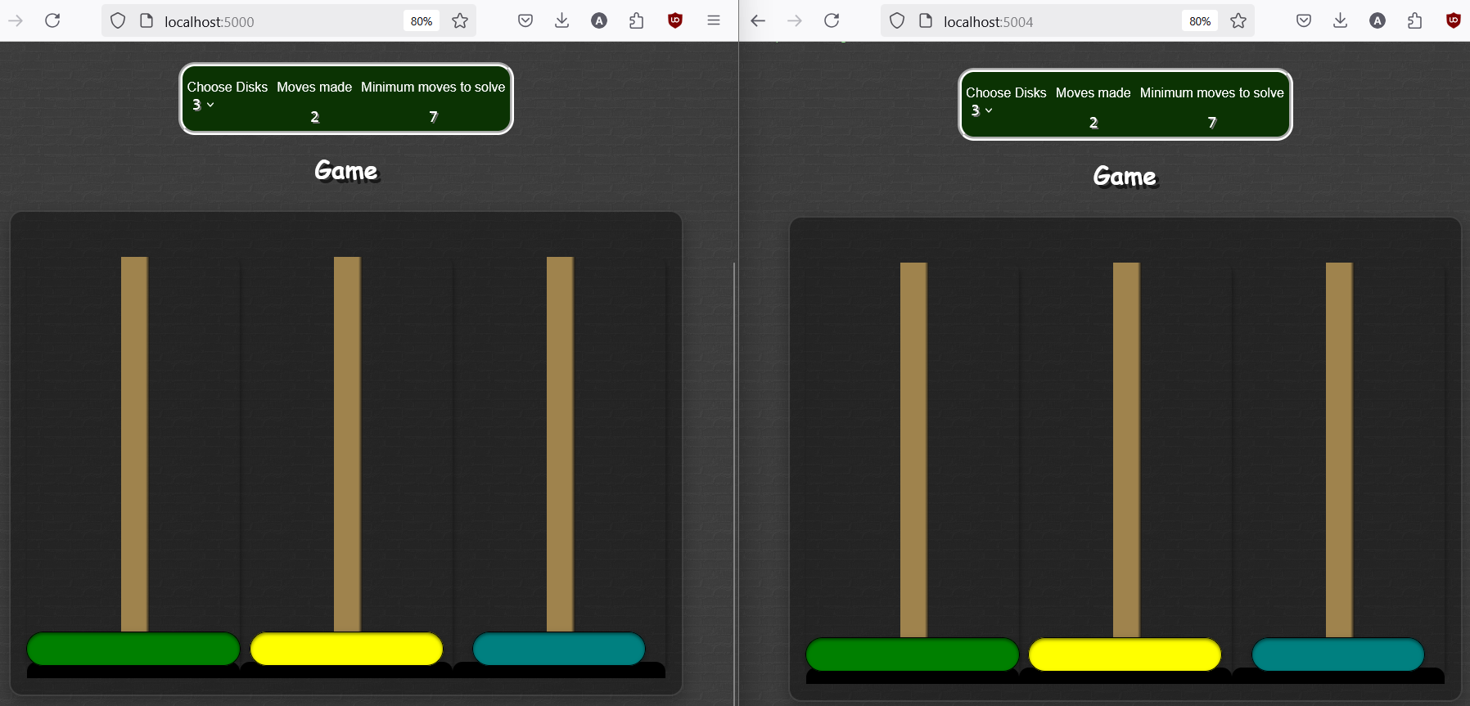

Fig: Updating the disk before browser refresh

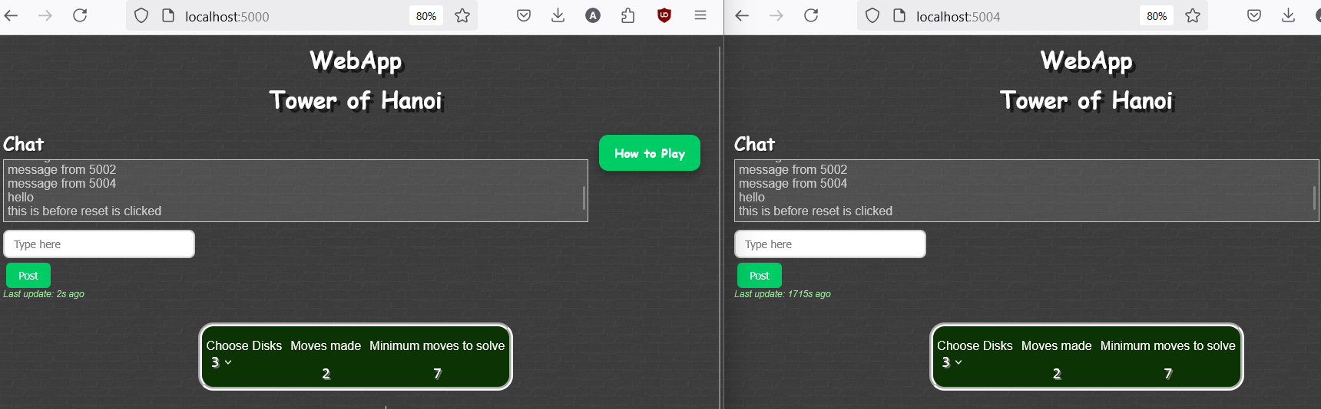

Fig: Chat state before browser refresh

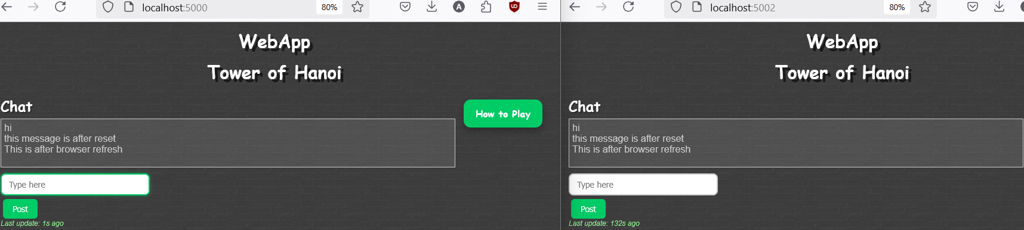

Fig: Chat updates lost after browser refresh

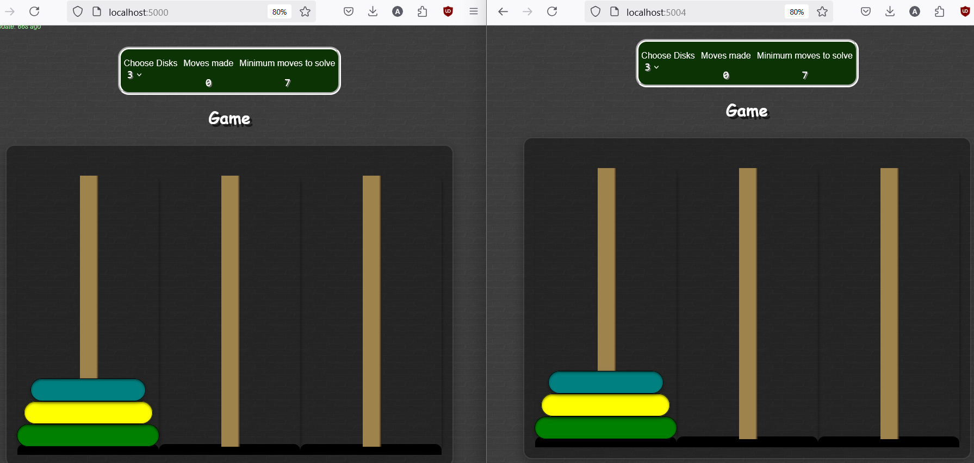

Fig: Disk state reset after browser refresh

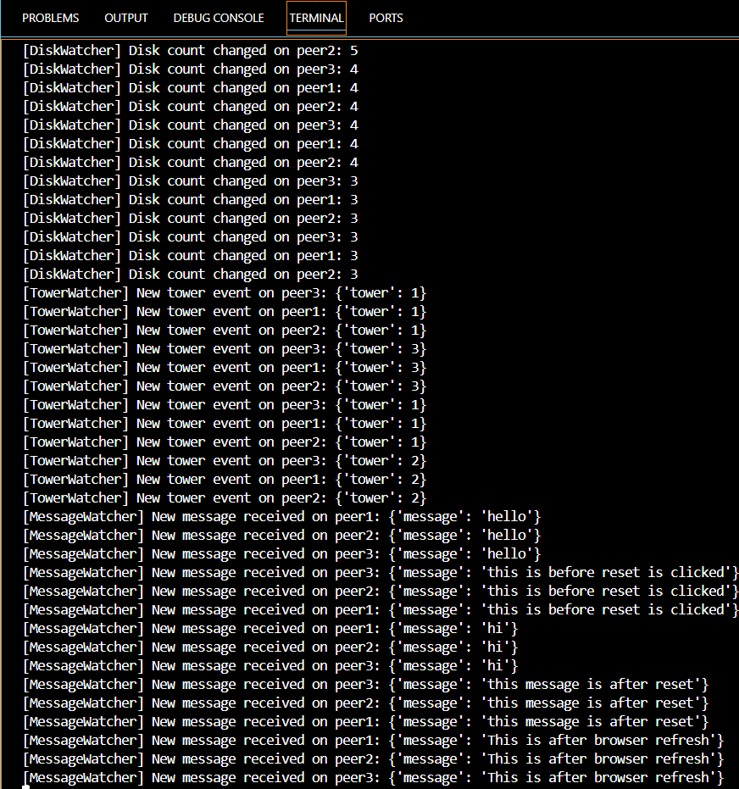

Fig: No updates for browser refresh in console

**Justification:** No session replay or persistent snapshot logic in current Zookeeper version.

### TC-7: Concurrent Message Posting

**Test Type:** Manual

**Description:** Send messages from multiple peers simultaneously and check for delivery.

**Expected:** All messages show up with minor ordering delays.

**Actual:** All messages received successfully.

**Status:** PASS

**Screenshots:**

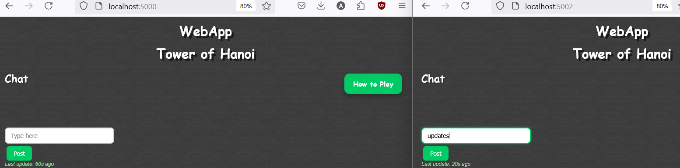

Fig: Before sending chat messages across peers

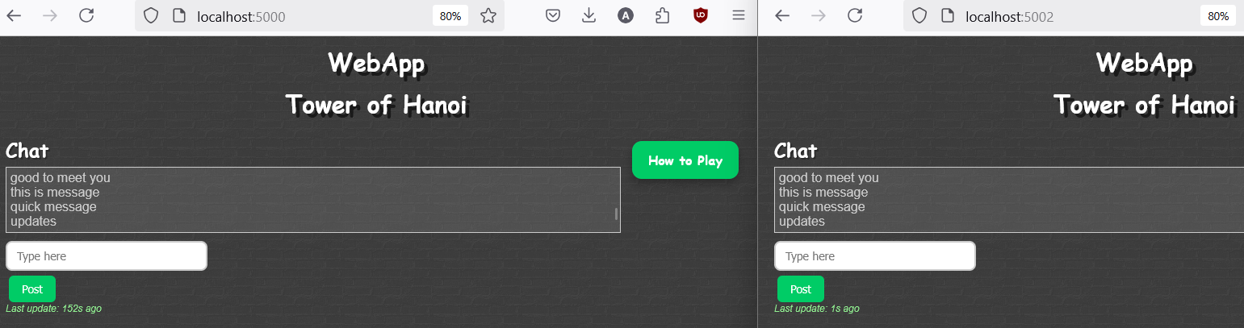

Fig: Chat updates with close to no lag

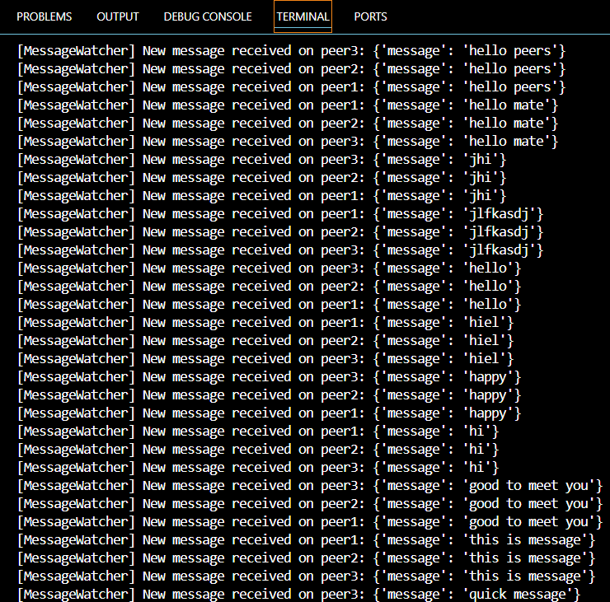

Fig: Concurrent Message updates in console with little to no lag

### TC-8: UI Responsiveness

**Test Type:** Manual

**Description:** Test UI buttons, dropdowns and layout for responsiveness.

**Expected**: UI components work smoothly across peers.

**Actual:** All interactive components responded without delay.

**Status:** PASS

**Screenshots:**

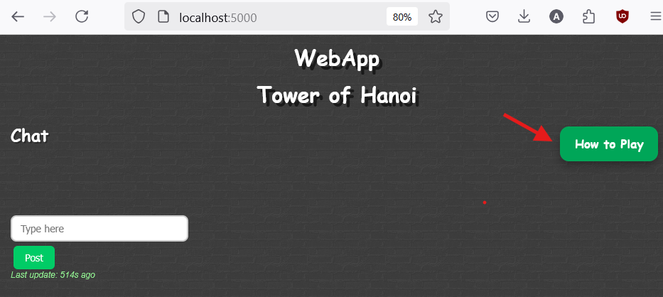

Fig: ‘How to Play’ button responds during hover

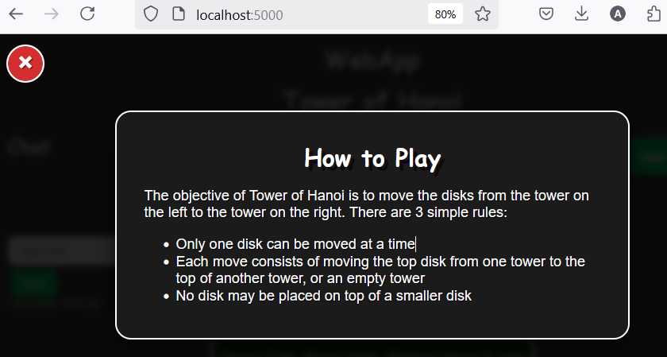

Fig: ‘How to Play’ button works and close button responds on hover

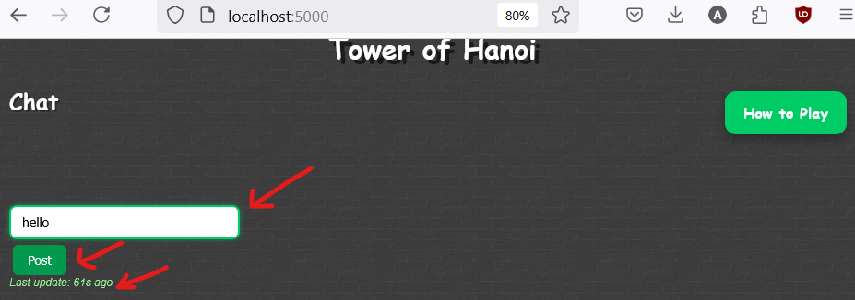

Fig: Chat UI is responsive

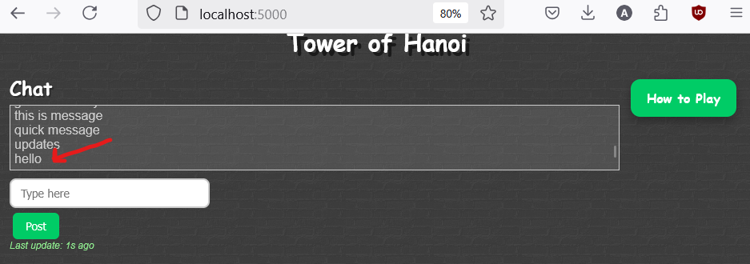

Fig: Chat messages are scrollable and clear

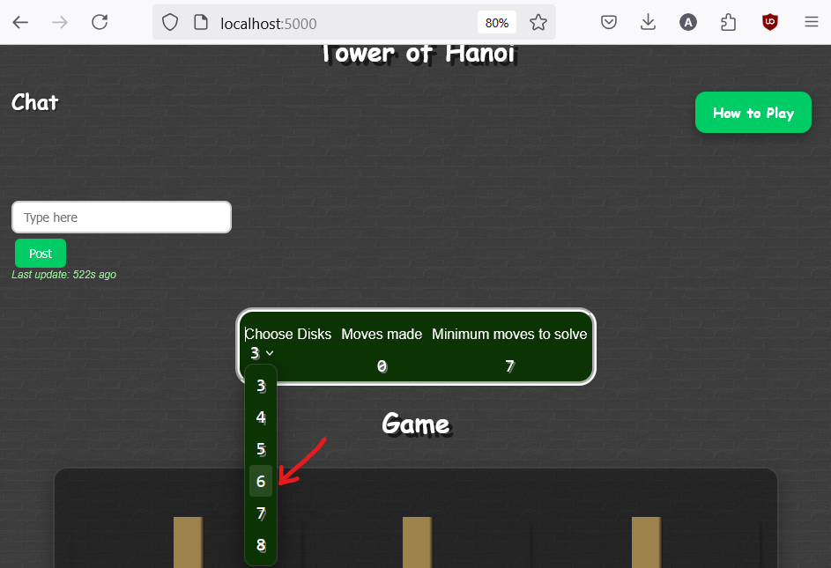Fig: Choosing Disks from responsive dropdown with hover

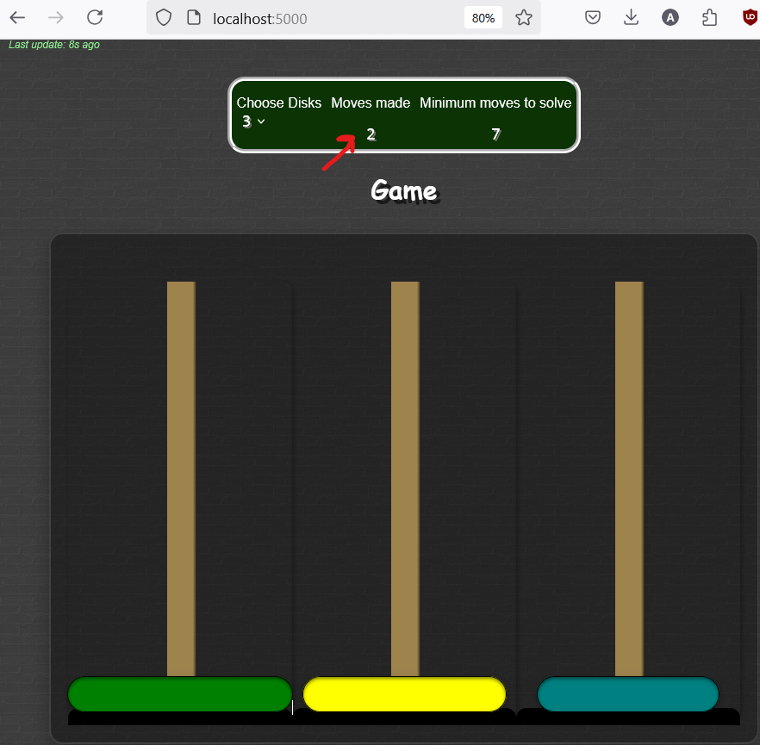

Fig: Moves made are updated and clearly visible

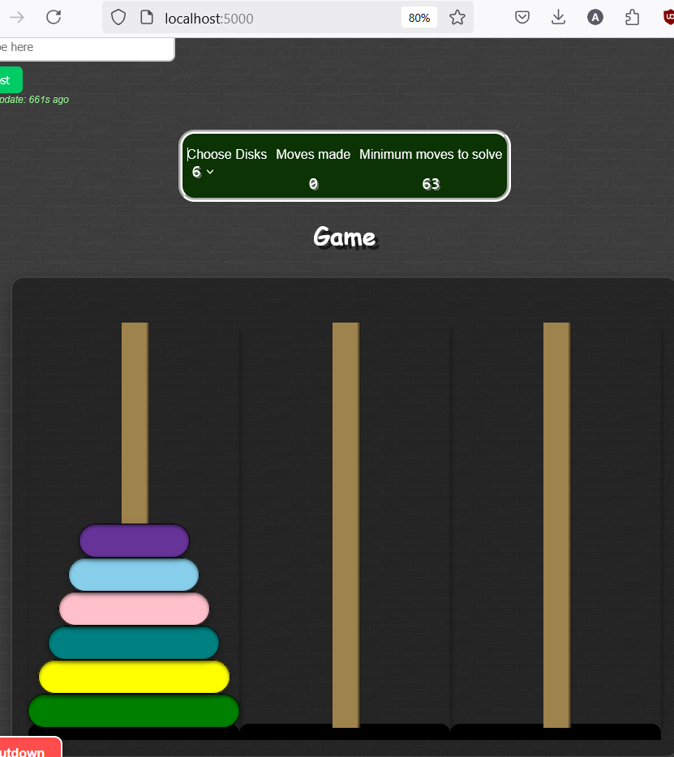

Fig: Disks are updated on the tower with choose disks option

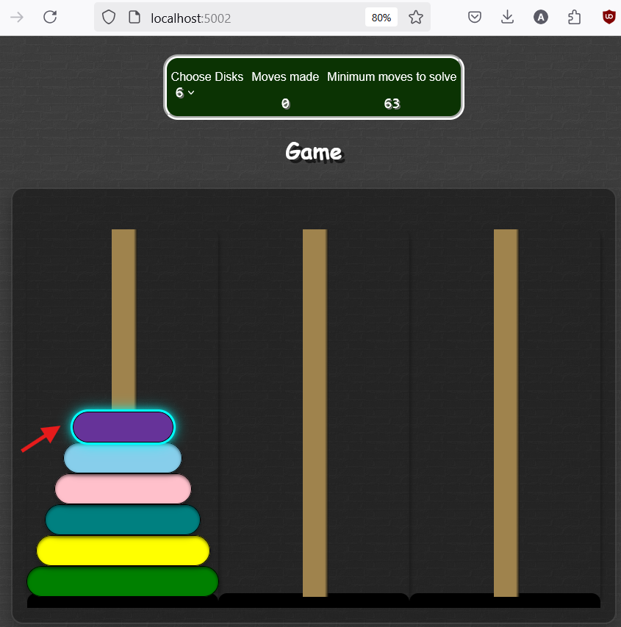

Fig: Disk gets highlighted when clicked

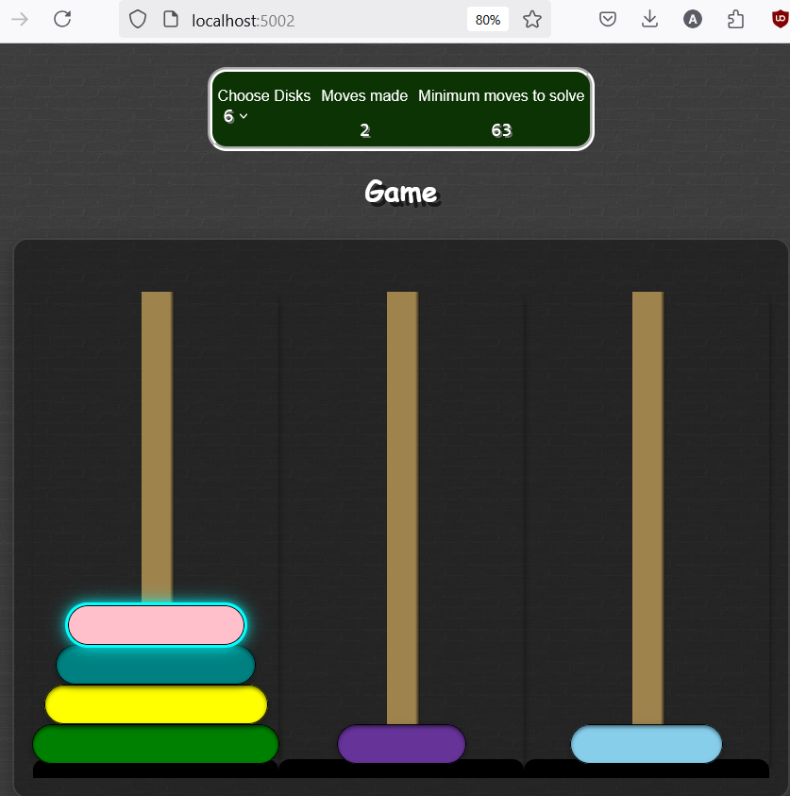

Fig: Disk moves in all towers across peers

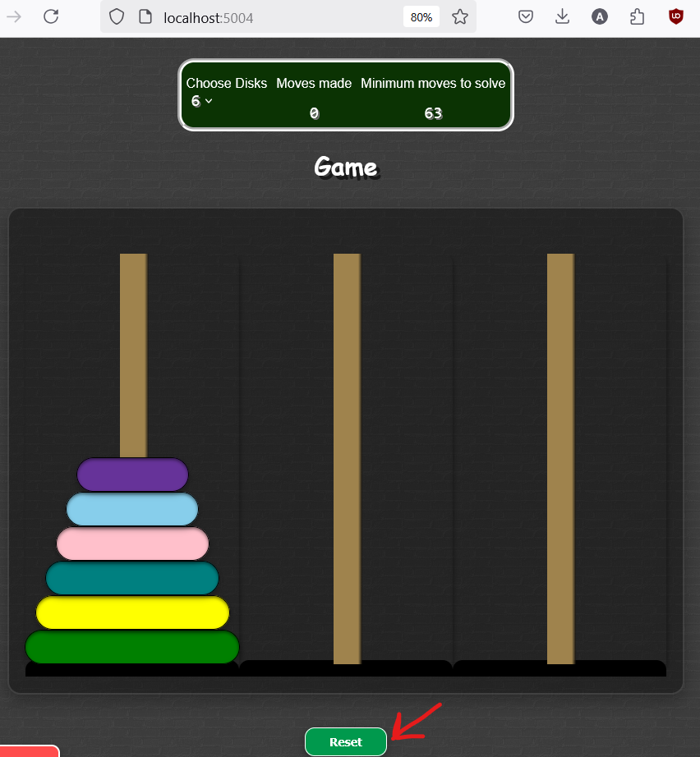

Fig: Reset button is responsive on hover

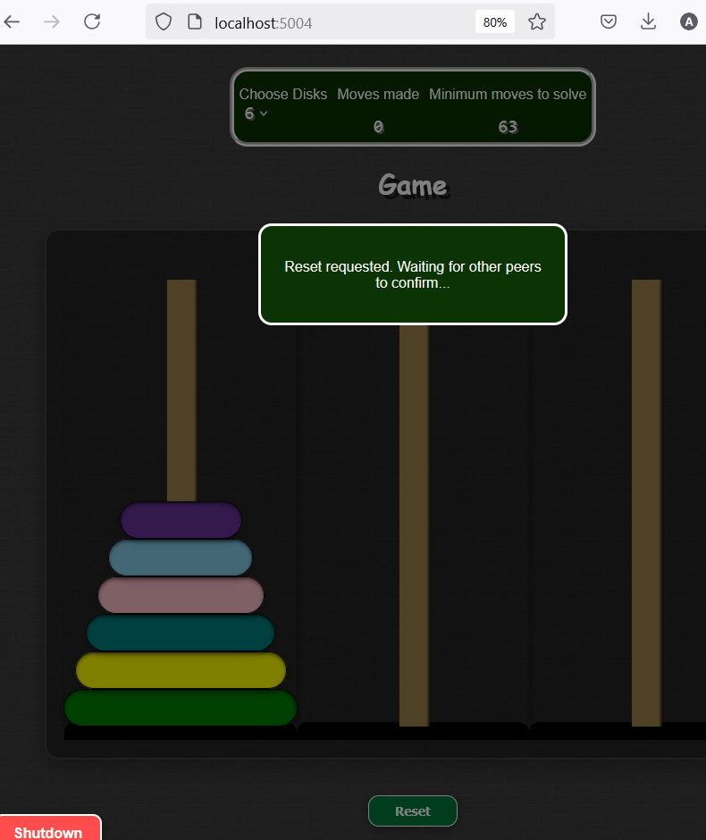

Fig: Reset button functions properly

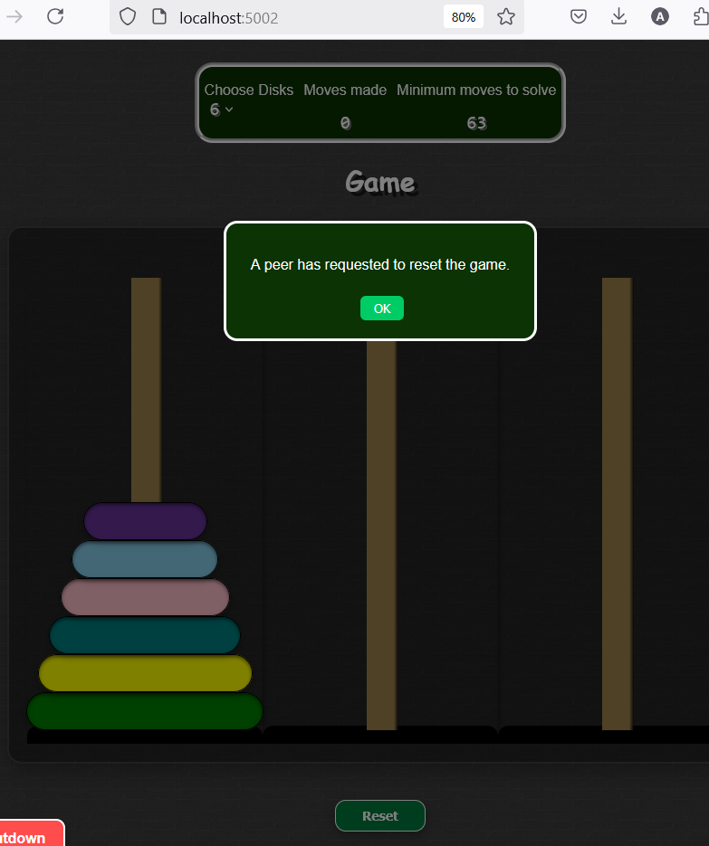

Fig: Reset request dialog is centered and has responsive button

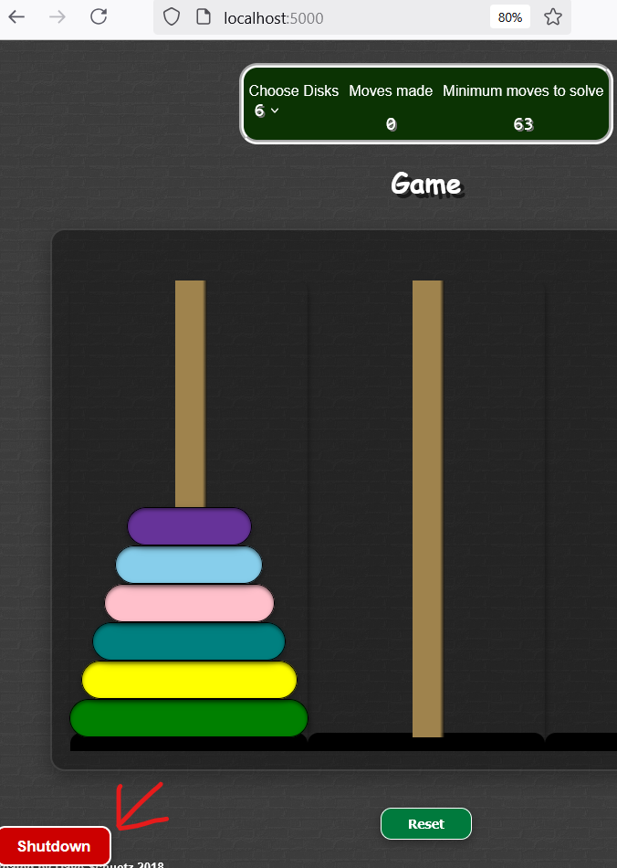

Fig: Shutdown button is responsive on hover

### TC-9: Shutdown Peer via Link

**Test Type:** Manual

**Description:** Click /shutdown and observe if peers disconnect gracefully.

**Expected:** Browser redirects or shows disconnection page.

**Actual:** Peer is killed, browser loses connection completely and live peer is unresponsive.

**Status:** FAIL

**Screenshots:**

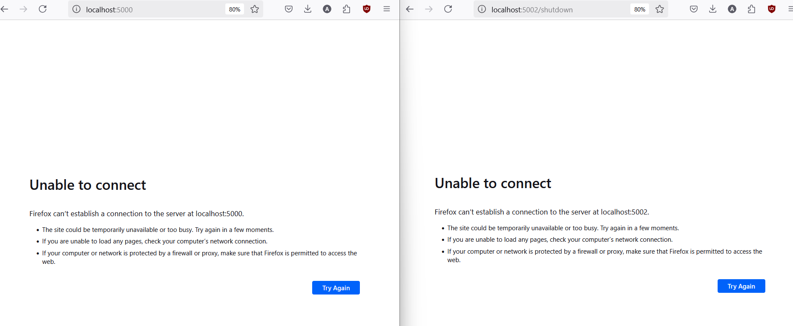

Fig: Shutdown button triggers kill process

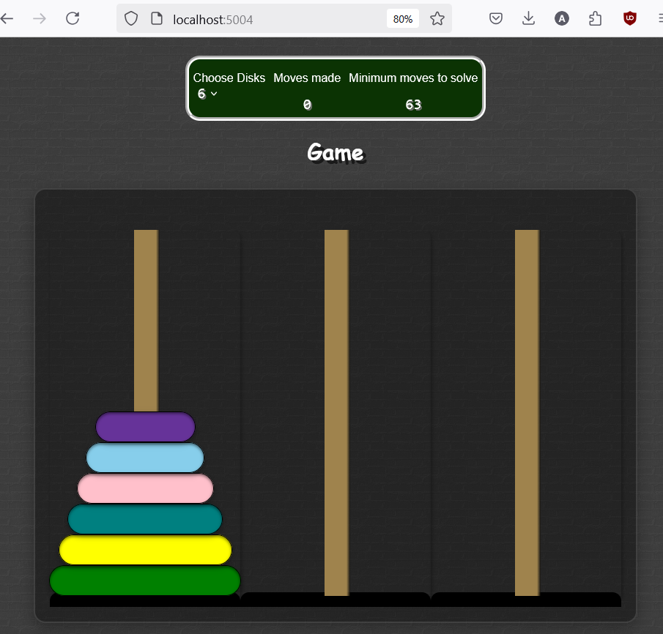

Fig: Remaining peer is unresponsive with updates

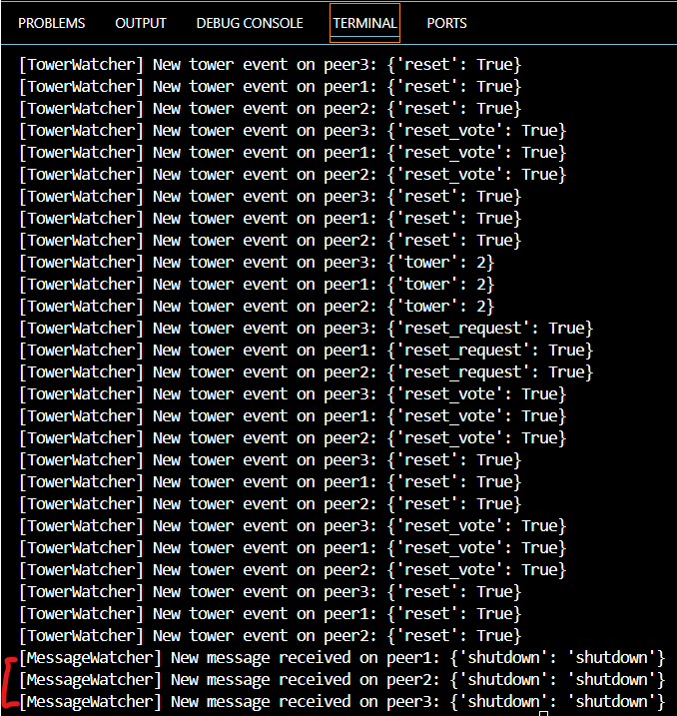

Fig: Shutdown update consistent in console

**Justification:** The shutdown intentionally triggers Flask termination to simulate crash for testing, but this version doesn’t include feature to maintain state of other live peers.

### TC-10: Disk Movement Test (3 to 8 Disks)

**Test Type**: Manual

**Description:** Start game with 3 disks, then increase to 8 and verify game adapts across peers.

**Expected:** Game interface re-renders till 8 disks correctly with some lag.

**Actual:** All peers updated their disk count and layout accordingly till 8 disks with minute lag.

**Status:** PASS

**Screenshots:**

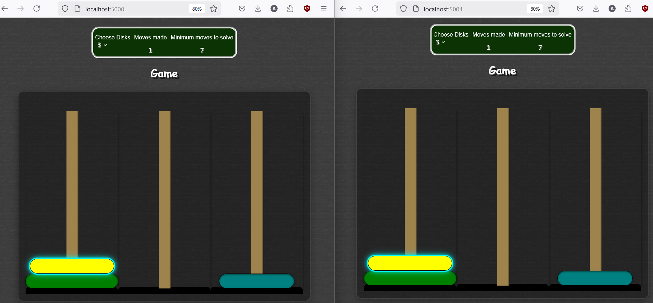

Fig: Random disk movement and selection with 3 disks across peers

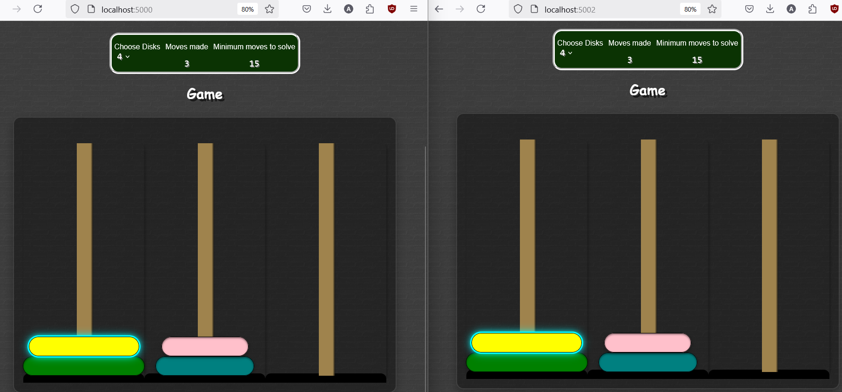

Fig: Random disk movement and selection with 4 disks across peers

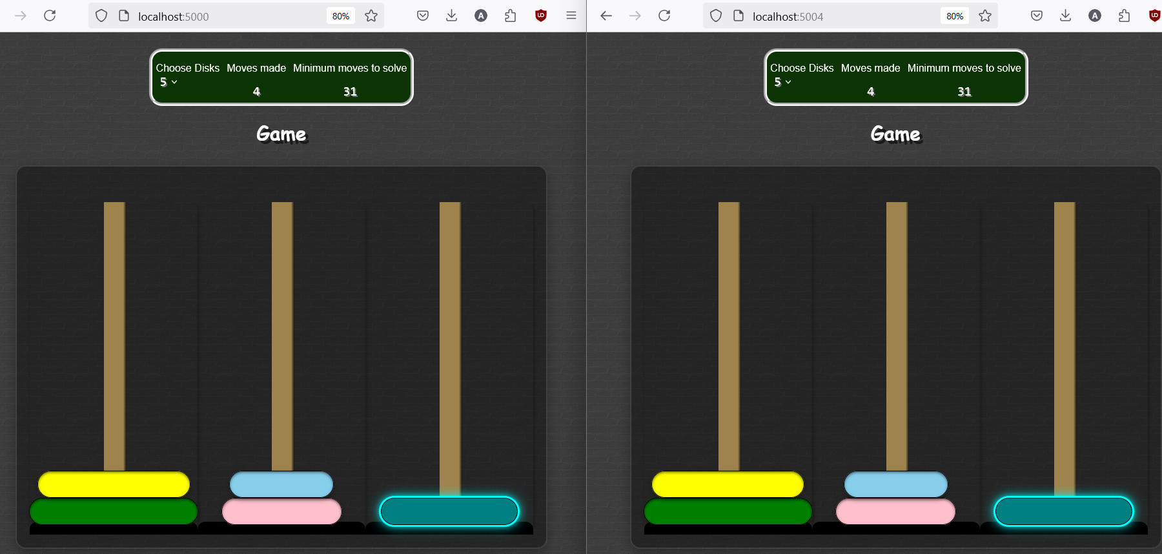

Fig: Random disk movement and selection with 5 disks across peers

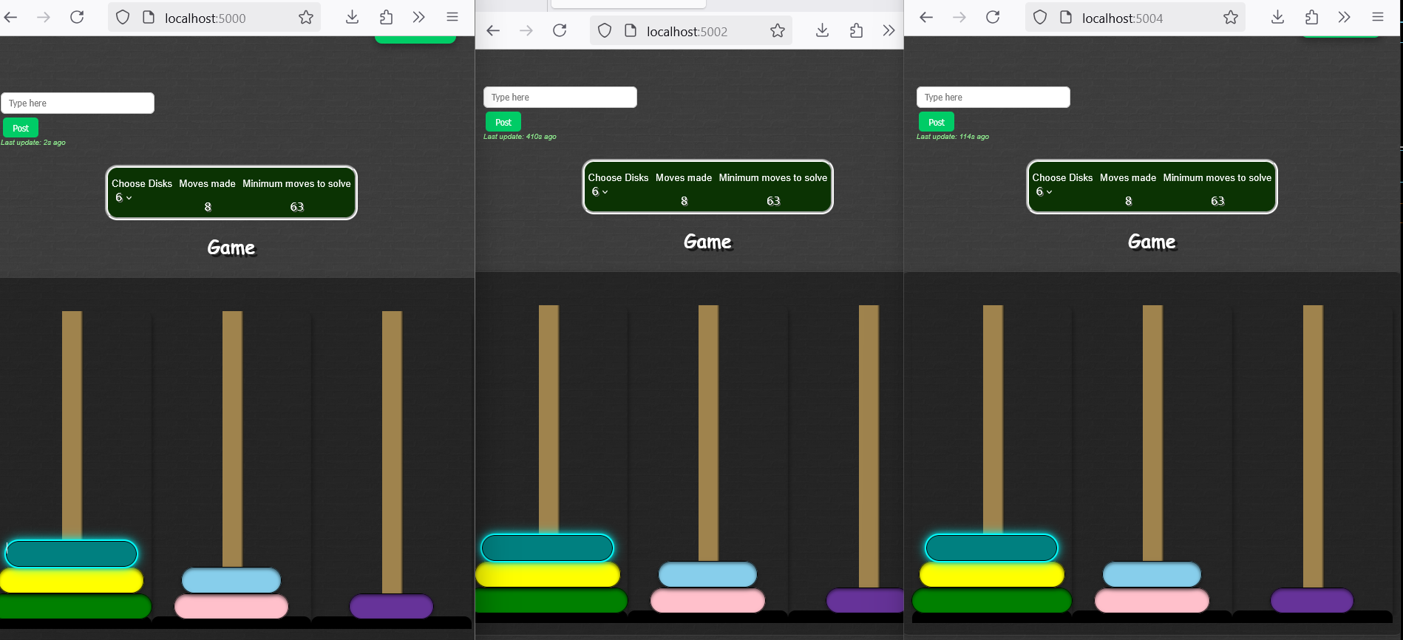

Fig: Random disk movement and selection with 6 disks across peers

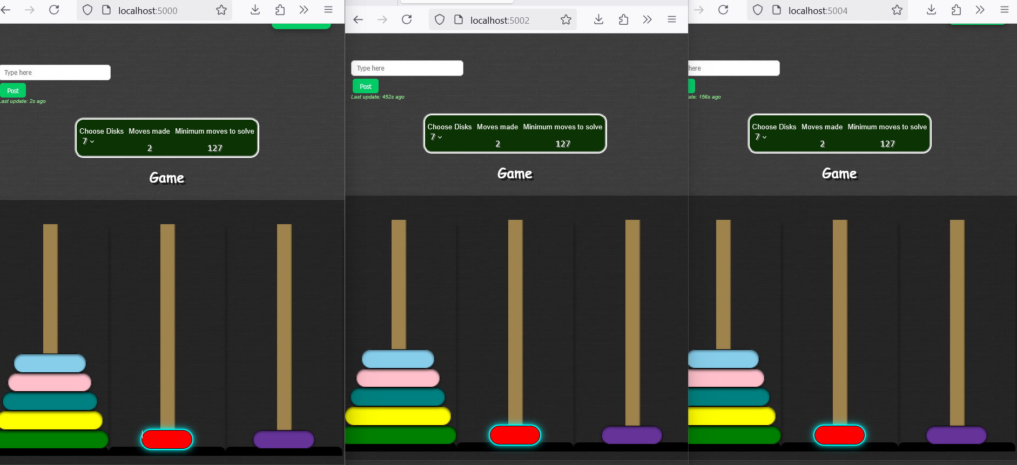

Fig: Random disk movement and selection with 7 disks across peers

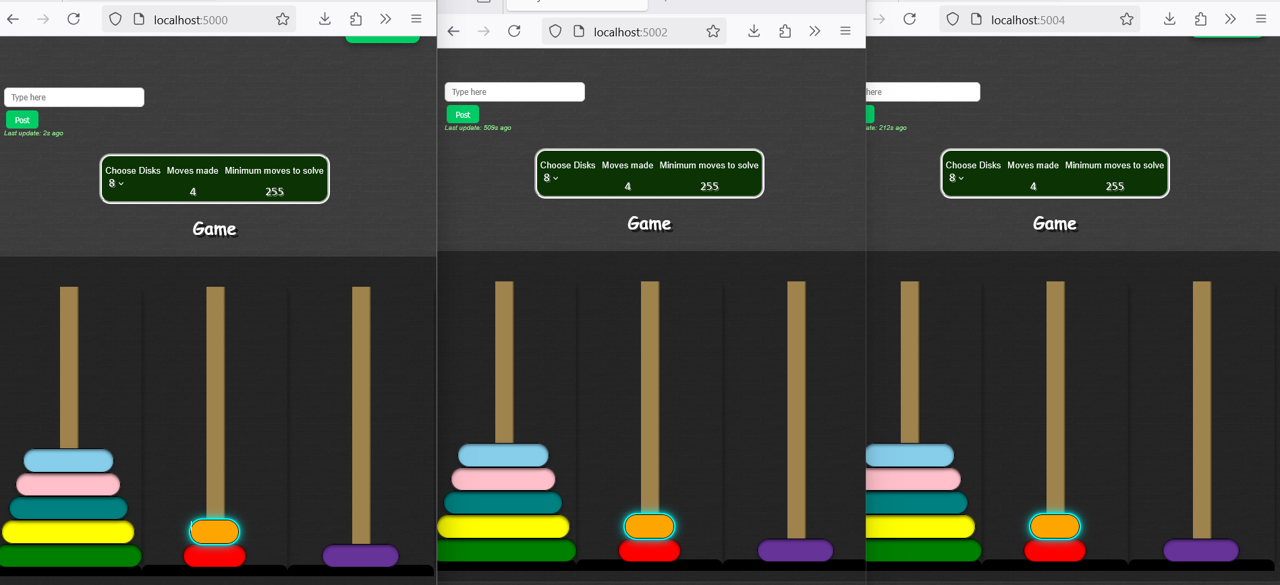

Fig: Random disk movement and selection with 8 disks across peers

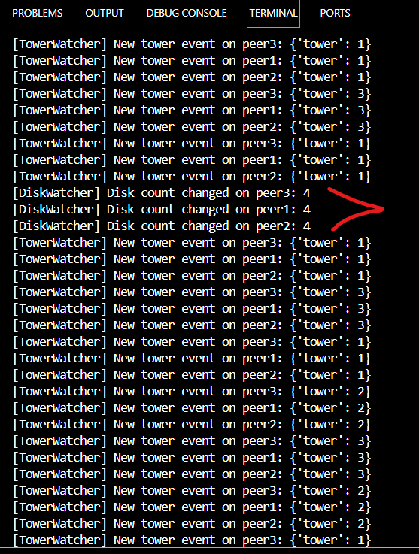

Fig: Disk changes and movements updates visible in console

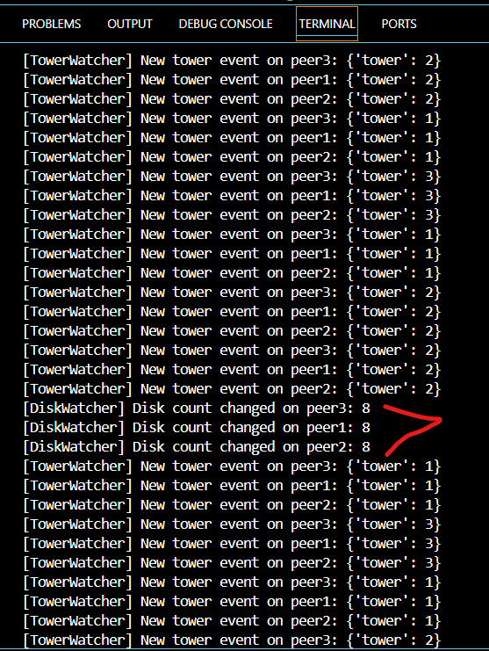

Fig: Disk changes and movements updates visible in console

# Test Summary

The Zookeeper version of coPlay was put through a mix of automated fault tolerance and manual functional tests to assess how well it performs in a multi-peer environment. The main focus was on message delivery, tower interactions, disk synchronization, and the system's ability to stay consistent across all connected users.

In the automated tests, message reordering and lag simulation passed smoothly. Messages sent in quick bursts arrived at the destination peers without being dropped or misinterpreted. Even with an artificial delay added, peers were still able to receive the messages properly. This shows that the system's polling and watcher setup is resilient enough to handle moderate real-world delays or timing differences between users.

One test that didn’t pass was the simulated crash scenario. When a peer was forcefully shut down in the middle of the session, it disconnected cleanly—but messages sent after that crash didn’t show up on all remaining peers. This behavior is expected because Zookeeper isn't a messaging queue; it doesn’t persist messages the same way. It requires active peers to fetch updates in near real-time, so if one crashes, those missed intervals won’t be automatically recovered.

Manual testing covered almost every interactive feature of the game. Changing the number of disks using the dropdown menu reflected correctly on all peers, including switching between 3 to 8 disks. Tower clicks and reset interactions worked well too. The reset mechanism, which requires one peer to request and another to vote, led to a synchronized game reset across all clients after a short delay.

We also tested browser refresh mid-session. While the refreshed peer lost its game state (which is a known limitation due to the lack of history replay), the other connected clients stayed completely unaffected. Reloading didn’t crash anything or cause inconsistencies elsewhere, which is a good sign for general stability.

The `/shutdown` endpoint, when triggered, disconnected that specific peer and stopped its Flask process entirely. This is intentional behavior to simulate a peer going offline abruptly. Naturally, this breaks the session for that peer (as it kills the process), but it's useful for testing how others react. The other peers are unresponsive.

Altogether, the Zookeeper version shows strong consistency and real-time coordination among peers. It handles chat, disk changes, and tower logic well. While it doesn’t include advanced state recovery or message deduplication, its current design meets the key functional and synchronization needs of the system, with a few expected limitations clearly identified and documented.

# Appendix

**Test code:**

# Helper to simulate a peer crash

def crash_peer(peer):

    try:

        requests.get(f"{BASE_URLS[peer]}/shutdown")

        print(f"Shutdown signal sent to Peer{peer+1}")

    except:

        print(f"Peer{peer+1} is unreachable or already shut down")

# Test crash during broadcast

def test_crash():

    print("\nRunning test_crash...")

    post_msg(0, "before crash")

    time.sleep(1)

    crash_peer(2)

    post_msg(1, "after crash")

    time.sleep(2)

    updates = get_updates(0)

    if any("after crash" in u.get("message", "") for u in updates):

        print("PASS: Message after crash received")

    else:

        print("FAIL: Message after crash not found")

# Test sending messages in order

def test_message_order():

    print("\nRunning test_message_order...")

    msgs = ["One", "Two", "Three"]

    for msg in msgs:

        post_msg(1, msg)

        time.sleep(0.5)

    updates = get_updates(0)

    received = [u["message"] for u in updates if "message" in u]

    if all(m in received for m in msgs):

        print("PASS: All ordered messages received")

    else:

        print("FAIL: Message(s) missing")

# Test delayed message arrival

def test_lag():

    print("\nRunning test_lag...")

    post_msg(0, "lag test")

    time.sleep(3)

    updates = get_updates(1)

    if any("lag test" in u.get("message", "") for u in updates):

        print("PASS: Lagged message received")

    else:

        print("FAIL: Lagged message missing")

# Run all tests if testing mode is enabled

if TESTING:

    time.sleep(2)

    test_message_order()

    test_lag()

    test_crash()

    print("\nAll tests finished.")